

**TRIP BUDGETER**

VENTURE BUDGET WANDER

2025

PREPARED BY

HUDA, AMNA ROMAN & ALIZA



Table of Contents

PROPOSED SOLUTION 4

FUNCTIONAL REQUIREMENTS 4

1) Home Page and Dashboard 4

2) User Management 4

a) User Registration and Login 4

b) User Profile Management 5

3) Trips 5

4) Expenses 5

5) Insights 5

6) Reports 5

General Functional Requirements 5

PROJECT PLAN 6

E-R DIAGRAMS 7

ALGORITHMS 8

GUI STANDARDS DOCUMENT 11

Color Theme 11

Typography 11

UI Components 11

Accessibility 12

INTERFACE DESIGN DOCUMENT 13

TASK SHEET 31

PROJECT REVIEW & MONITORING REPORT 32

UNIT TESTING CHECKLIST 33

FINAL CHECKLIST 34

# PROPOSED SOLUTION

To make it easier for users, a Mobile App titled Trip Budgeter is to be developed. This mobile app will enable users to register, and thereafter facilitate efficient and user-friendly tracking of travel expenses and more. The app will cater to individual travelers as well as groups, ensuring seamless and collaborative expense tracking.

# FUNCTIONAL REQUIREMENTS

The Trip Budgeter mobile application will be designed as a set of forms/pages, navigation, and fragments/screens with menus representing different activities. The following outlines the functional requirements of the application:

## 1) Home Page and Dashboard

The home page will feature attractive visuals and menus for various operations, including basic functionality such as Registration and Login. Once logged in, users will be able to access a range of menus.

Features:

• Overview – Quick summary of current trip expenses, remaining budget, and recent activity.

• Trip Summary – Detailed view of the selected trip including total expenses, budget, and categorization of expenses.

## 2) User Management

### a) User Registration and Login

Allows new users to register with Trip Budgeter. Registration details include email address, full name, address, age, gender, username, and password. Appropriate error-checking will be implemented, such as validating the format of the email address. Upon successful registration, a welcome email will be sent to the user.

• ADMIN – Can log in to the app to add destinations, trips, itineraries, currency, and exchange rates.

• USER – Can log in after registration to access app features. The username will be displayed at the top-right corner after login.

### b) User Profile Management

Users can create and edit their profile, including personal information, preferred currency, and travel preferences. They can also upload a profile picture.

## 3) Trips

• Create a New Trip – Form to input trip name, dates, destination, and budget.

• Active Trips – List of ongoing trips with quick access to details and expenses.

• Completed Trips – Archive of past trips with access to related expenses and reports.

## 4) Expenses

• Add Expense – Input amount, category, date, and notes.

• View All Expenses – Comprehensive list with filters for date, category, and amount.

• Categories – Manage expense categories by adding or editing entries.

## 5) Insights

• Budget Tracking – Real-time tracking with remaining budget display.

• Notifications and Alerts – Customizable alerts for budget limits, high spending, and reminders.

## 6) Reports

• Generate Report – Create detailed expense reports by date range, category, and filters.

• View Past Reports – Archive of previously generated reports for reference.

## General Functional Requirements

• GPS functionality as applicable.

• Home Page – Modules for both User and Admin.

• About Us – Description of services offered by the app.

• Image Gallery – Showcase various travel destinations.

• Contact Us – Form with name, email, contact number, and message fields.

• Search, Sort, and Filter – Options to refine trips by budget, location, etc.

# PROJECT PLAN

|  |  |  |  |
| --- | --- | --- | --- |
| Day | Task |  |  |
| Day 1 | Requirement Gathering, UI/UX Design Mockups |  |  |
| Day 2 | Firebase Setup, Database Structure Design |  |  |
| Day 3 | Backend Trip CRUD API Development, Frontend Trip List Integration |  |  |
| Day 4 | Expense Module Development, Reports UI |  |  |
| Day 5 | Final Testing, Debugging, Documentation, Submission |  |  |

# E-R DIAGRAMS

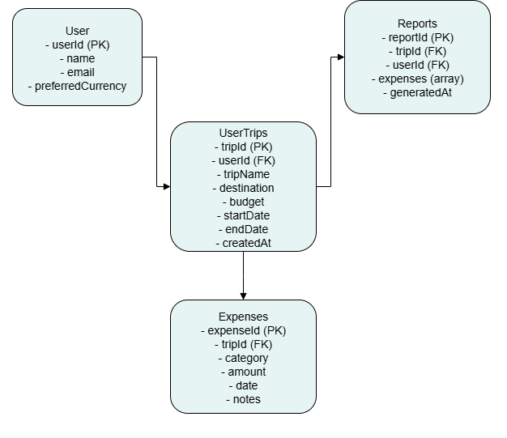

# ALGORITHMS

Level 0 - Context Diagram:

Overview of user and admin interactions with the Trip Budgeter App.

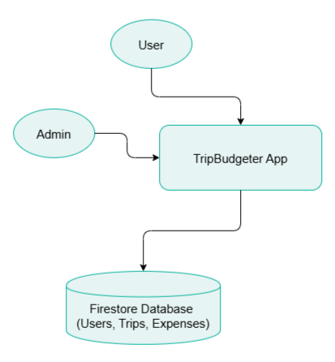

Level 1 – DFD:

High-level view of user management, trip management, and reporting processes.

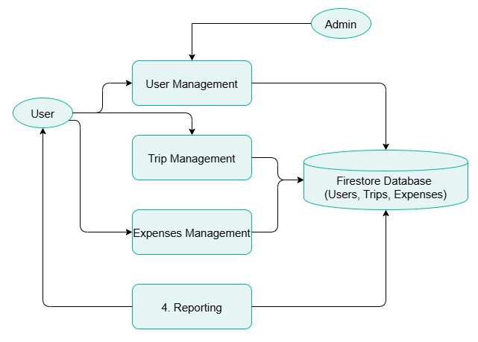

Level 2 – DFD:

Detailed flow of trip creation, expense recording, budget calculation, and report generation.

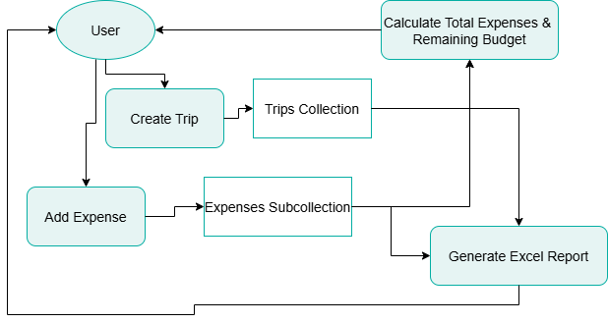

# GUI STANDARDS DOCUMENT

This document outlines the graphical user interface (GUI) standards for the Trip Budgeter Mobile App. It defines the main theme colors, text colors, background colors, and general style guidelines to ensure a consistent and user-friendly visual experience across all screens and components.

## Color Theme

The following colors form the core color palette for the Trip Budgeter app UI:

|  |  |  |
| --- | --- | --- |
| **Element** | **Color (Hex)** | **Sample** |
| Main Theme Color | #00A398 |  |
| Background Color | #F8FCFC |  |
| Dark Text Color | #0C1D1B |  |
| Light Text Color | #45A19B |  |

## Typography

The app uses clear and readable fonts with consistent size and weight for various text elements:  
- Headings: Bold, size 18-24 pt. , Dark Text Color  
- Body Text: Regular, size 14-16 pt. , Dark Text Color  
- Secondary Text: Italic or lighter weight, size 12-14 pt. , Light Text Color

## UI Components

Buttons:  
- Use Main Theme Color for primary buttons with white text.  
- Use Light Text Color for secondary buttons with background as Background Color.  
  
Input Fields:  
- Background Color: White or Background Color.  
- Border: Thin, using Light Text Color.  
  
Navigation Bar:  
- Background: Main Theme Color.  
- Icons and Text: White or Light Text Color for contrast.  
  
Alerts and Notifications:  
- Use Main Theme Color for positive alerts.  
- Use darker reds or greys for warnings/errors.

## Accessibility

Ensure sufficient contrast between text and background colors for readability.  
Use accessible font sizes and avoid overly bright or saturated colors.  
Provide alternative text for icons and images.

# INTERFACE DESIGN DOCUMENT

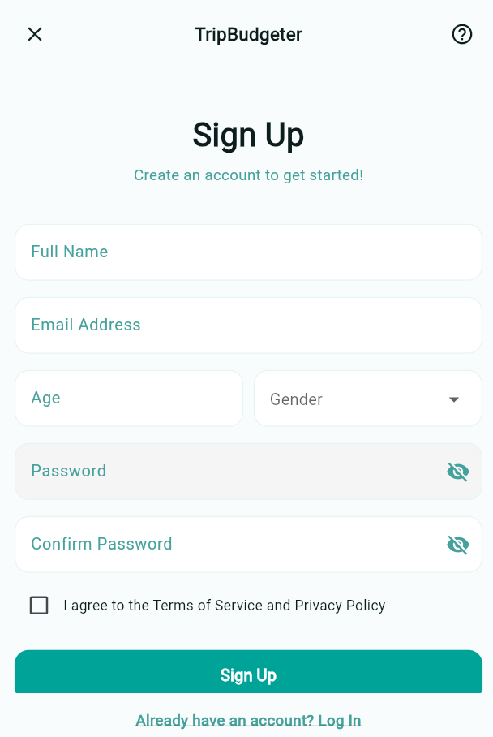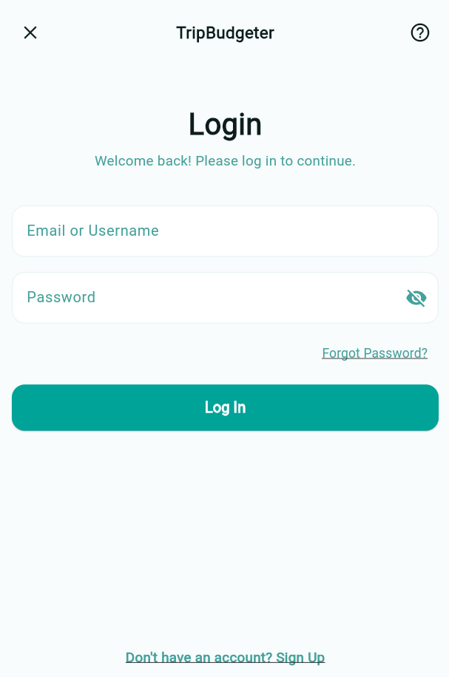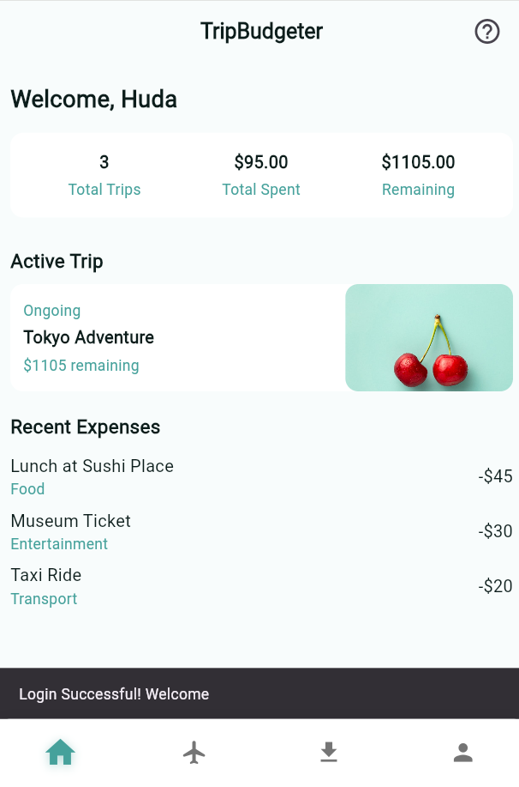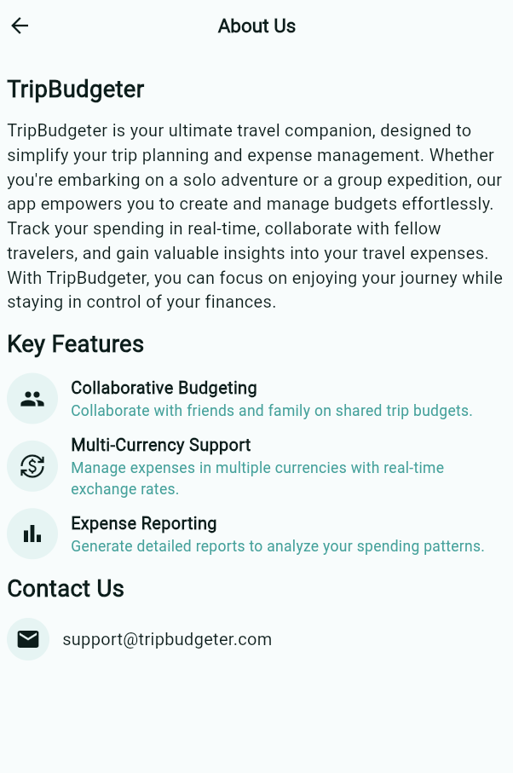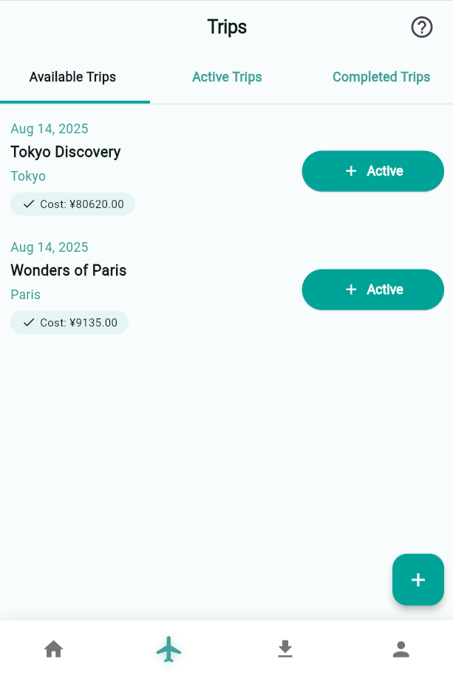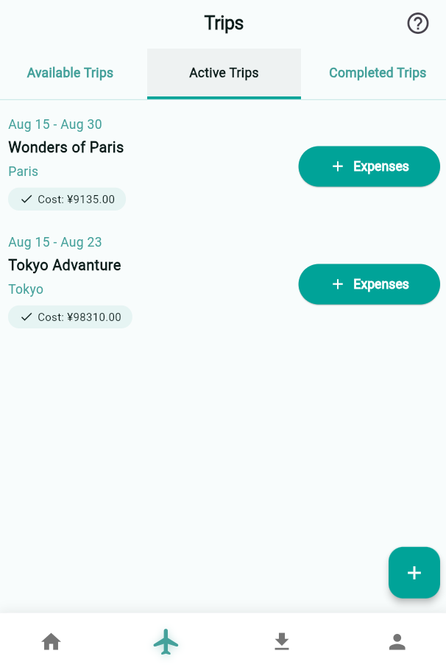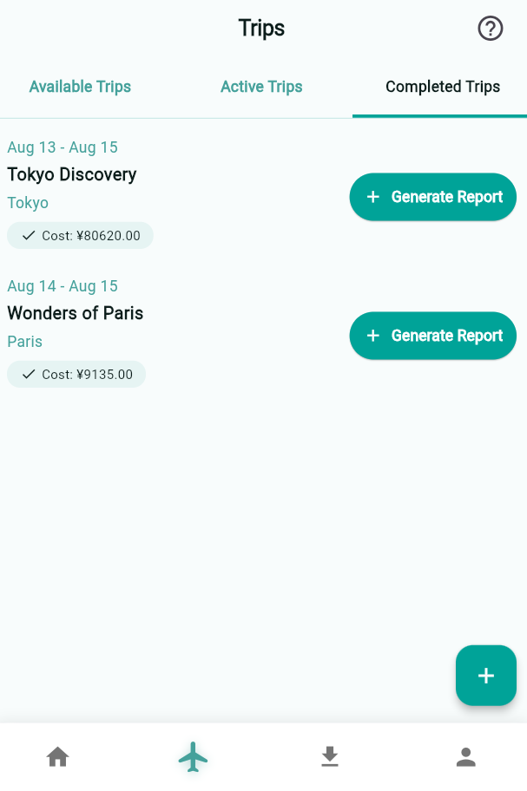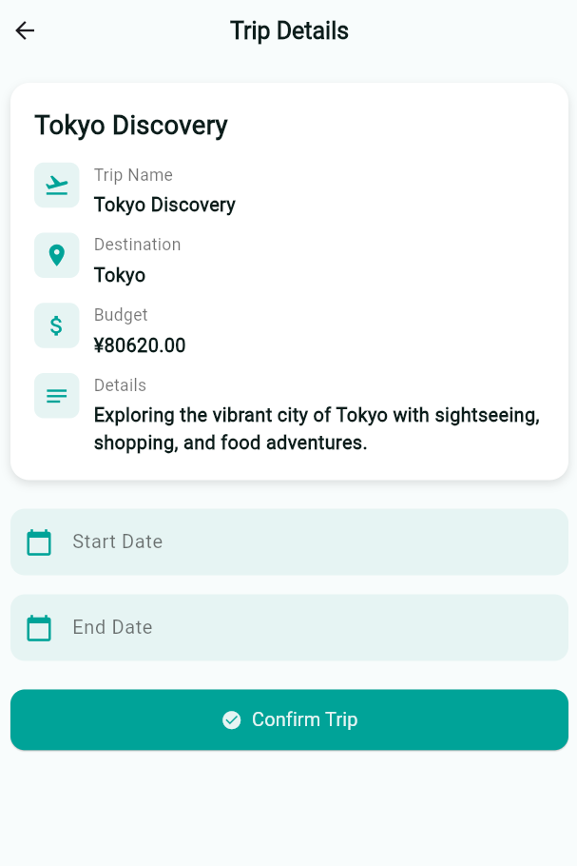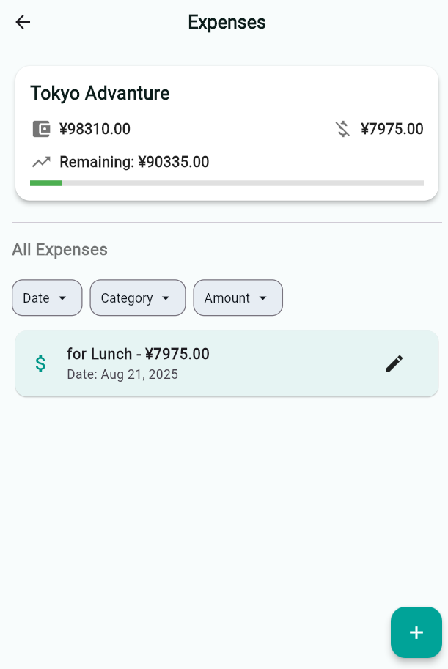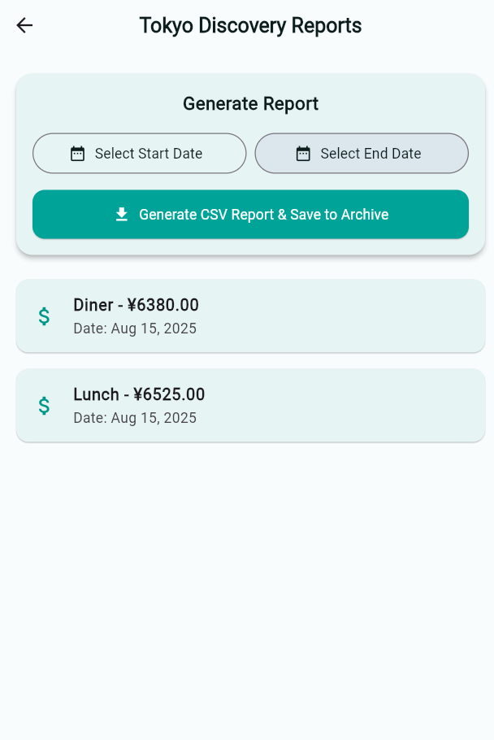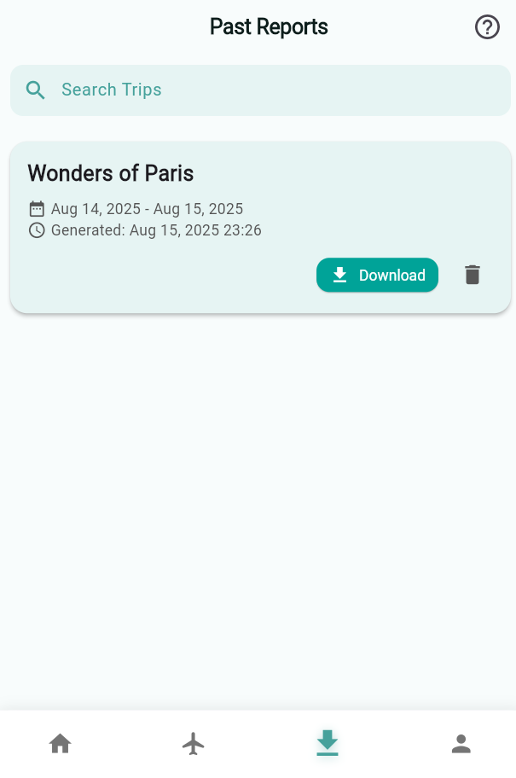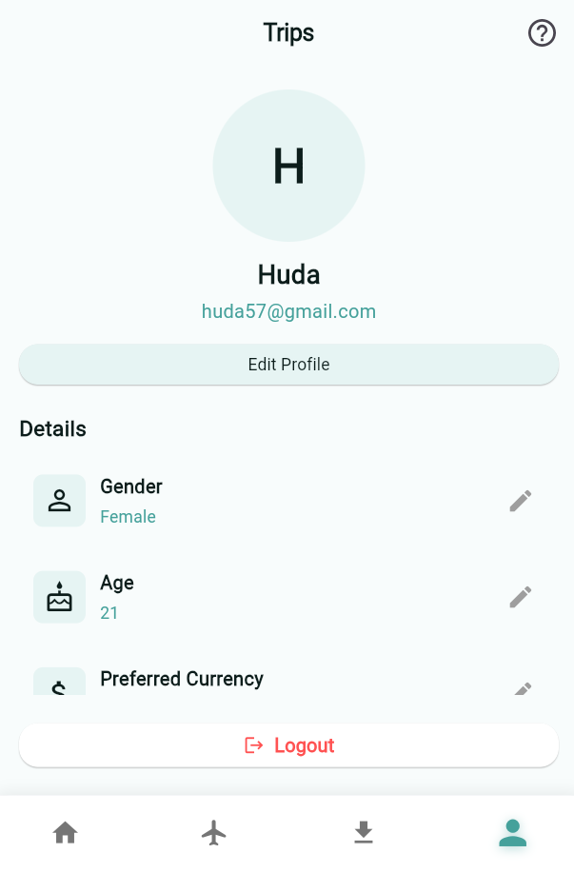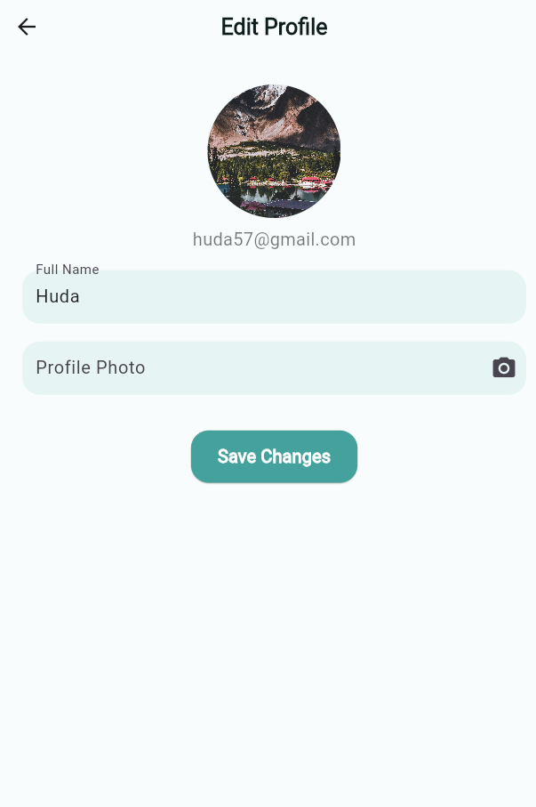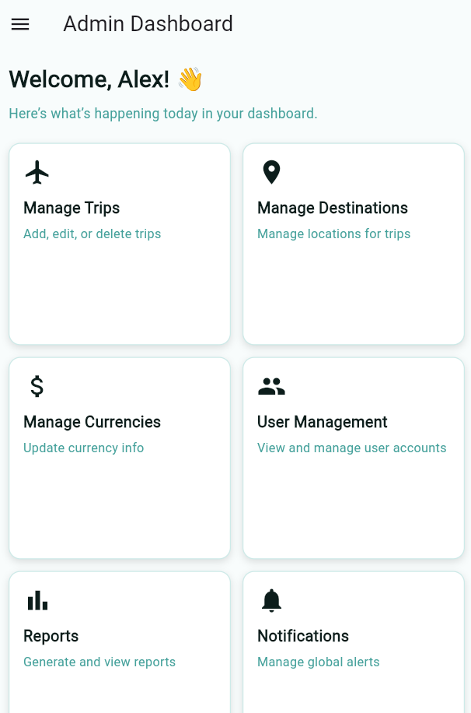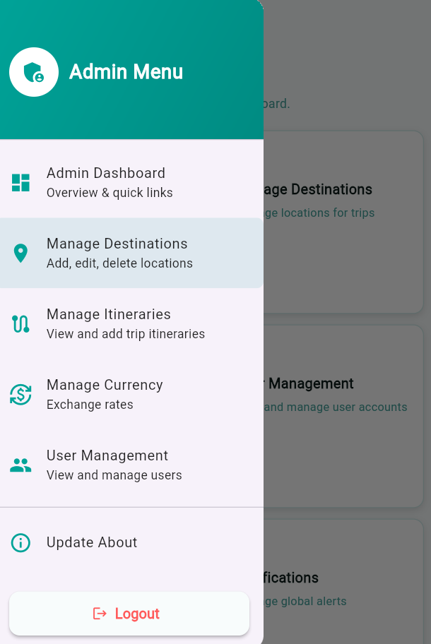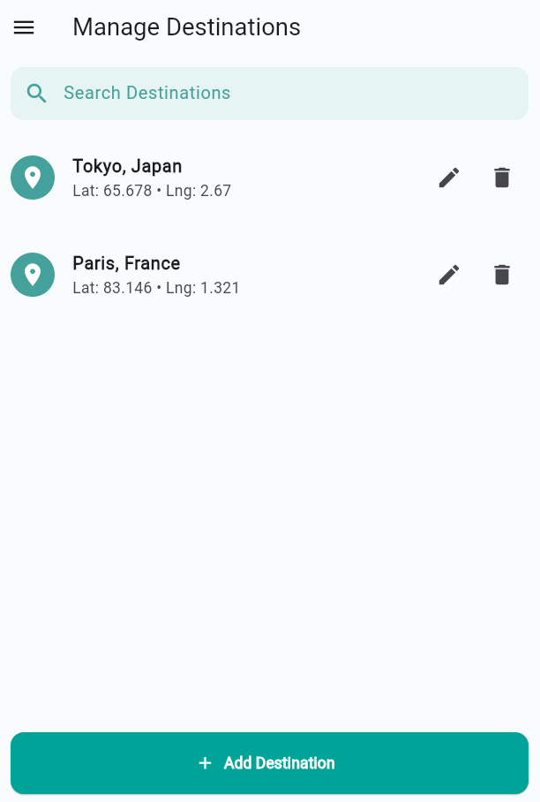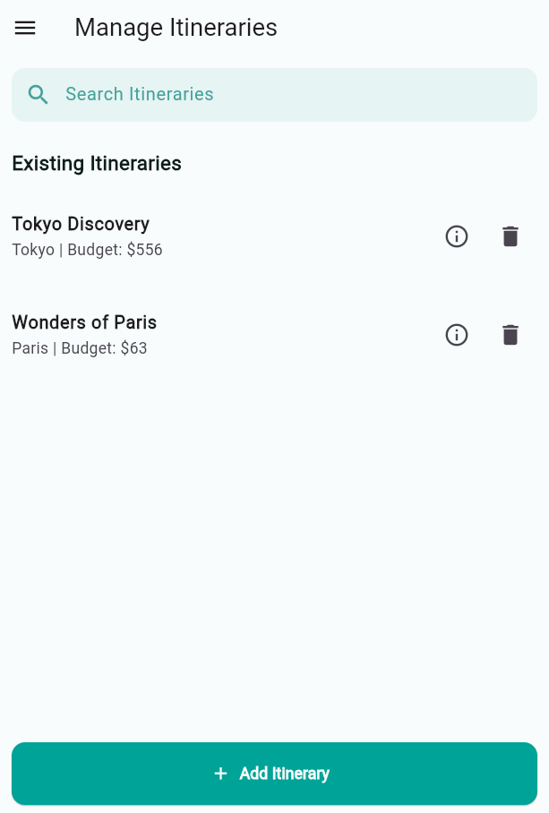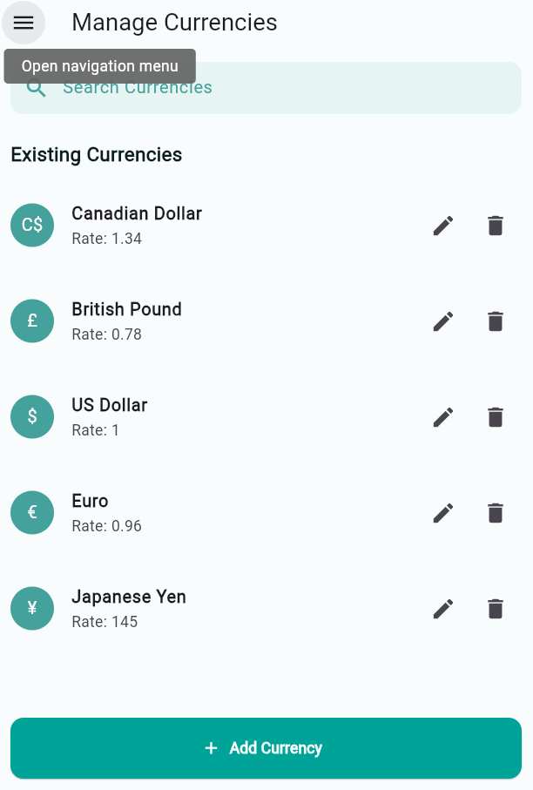

# TASK SHEET

**Project Title**: TripBudgeter Mobile App

**Date of Preparation of Activity Plan:** 11-August-2025

|  |  |  |  |  |
| --- | --- | --- | --- | --- |
| Sr.No. | Task | Actual Start Date | Actual Days | Remarks |
| 1 | Requirement Analysis & Planning | 11-August-2025 | 1 | Finalized functional requirements and scope |
| 2 | UI/UX Design (Wireframes & Mockups) | 11-August-2025 | 1 | Created mockups for all main screens |
| 3 | Backend Setup & Database Configuration | 11-August-2025 | 1 | Set up project structure and database schema |
| 4 | Frontend Development – Core Screens | 12-August-2025 | 1 | Built Home, Login, and Registration screens |
| 5 | Backend API Development – Authentication & Trips | 12-August-2025 | 1 | Developed authentication and trip creation APIs |
| 6 | Integration – Frontend & Backend | 13-August-2025 | 1 | Connect UI with APIs and dynamic data |
| 7 | Testing & Debugging | 14-August-2025 | 1 | Full system testing and bug fixes |
| 8 | Final Deployment & Documentation | 14-August-2025 | 1 | Prepare final deliverables |

# PROJECT REVIEW & MONITORING REPORT

The TripBudgeter Mobile App project commenced on 11-August-2025 with the Requirement Analysis and Planning phase. All team members participated in reviewing the provided functional requirements, clarifying scope, and preparing the feature list.  
  
The same day, the frontend team (Amna, Roman, Aliza) created detailed wireframes and mockups for all primary screens including splash, login, registration, dashboard, trip summary, and expense management pages. In parallel, the backend developer (Huda) set up the backend structure, configured the database, and prepared the initial ER diagram.  
  
On 12-August-2025, the frontend developers began building the Home Page, Login Screen, and Registration Screen, ensuring responsiveness and user-friendly navigation. Meanwhile, Huda worked on backend APIs for user authentication, trip creation, and budget tracking logic.  
  
13-August-2025 is dedicated to integrating frontend UI with backend APIs. All members will collaborate to ensure correct data flow, live budget tracking, and trip expense management features are functioning as intended.  
  
On 14-August-2025, the focus will be on Testing & Debugging to address any UI inconsistencies, API errors, or performance bottlenecks. The same day, final deployment and documentation will be completed, delivering a functional, polished version of the TripBudgeter Mobile App.

# UNIT TESTING CHECKLIST

|  |  |  |  |
| --- | --- | --- | --- |
| Sr. No. | Particulars | Yes | No |
| 1 | Have all the modules been properly integrated and are they completely functional? | Yes |  |
| 2 | Does each unit meet its objective and purpose? | Yes |  |
| 3 | Have all validations been implemented as per process design? | Yes |  |
| 4 | Have all design and coding standards been followed and implemented? | Yes |  |
| 5 | Is the GUI design consistent all over? | Yes |  |
| 6 | Are the codes working as per the specification? | Yes |  |
| 7 | Does the application’s functionality resolve the client problem and satisfy requirements? | Yes |  |
| 8 | Additional features and utilities that give value addition to the entire project. | Yes |  |

# FINAL CHECKLIST

|  |  |
| --- | --- |
| Option | Validated |
| Do all form fields have default values or proper placeholders where applicable? | Yes |
| Does the administrator have full rights to manage destinations, trips, and currency rates? | Yes |
| Are all user inputs and trip data properly stored in the database? | Yes |
| Have all modules been fully integrated and tested? | Yes |
| Have coding standards and best practices been followed? | Yes |
| Is the UI/UX design consistent across all screens? | Yes |
| Is the navigation flow smooth between Home, Trips, Expenses, and Dashboard? | Yes |
| Is proper error and exception handling implemented? | Yes |
| Are all feature codes working as intended? | Yes |